

**Course plan**

**Mashhad University of Medical Sciences**

**Department of English Language**

|  |  |
| --- | --- |
| **Title:** General English (Group 10) | **Field and degree of education:** Medicine (MD) |
| **Time:** Sundays (08-10 a.m.) & Tuesdays (10-12 a.m.) | **Place:** Faculty of Medicine |
| **Lecturer name:** Masoumeh Hassanpour, PhD Candidate in TEFL | **E-mail address:** hassanpourm1@mums.ac.ir |

* **General objectives:**

Improving student's reading and comprehension skills

* **Specific objectives:**

Student should be able to:

* read and understand lower intermediate to intermediate medical texts.
* learn and use reading strategies.
* recognize and use cohesive and discoursal devices in the texts.
* scan and skim to find out main idea and details.
* analyze complex sentences to understand the meaning.
* learn 800 to 1000 new vocabularies.
* improve pronunciation.
* **Main references:**
* English for the Students of Medicine I, Dr. R. Deedari & Dr. M. Ziyahossaini, 1395, SAMT, Selective units
* The Most Common Words Used in Medical Texts (M.N. Shafiee, 1397, Parastarane Javan)

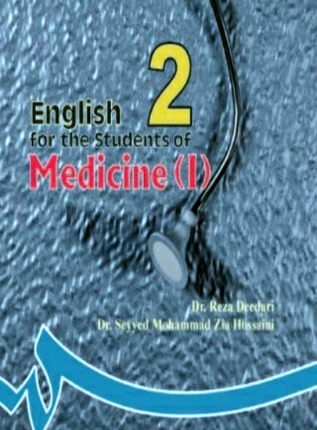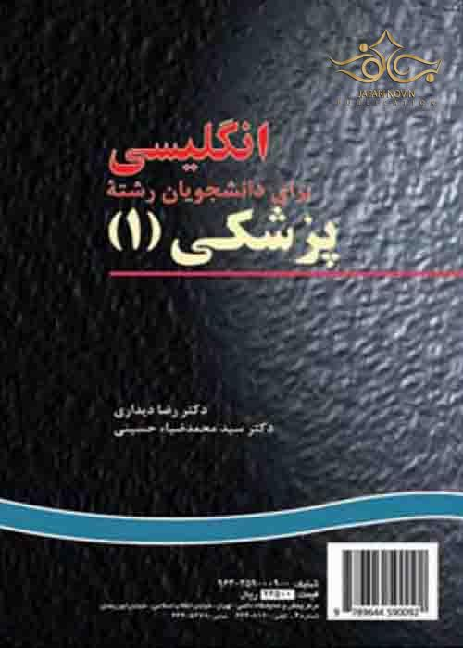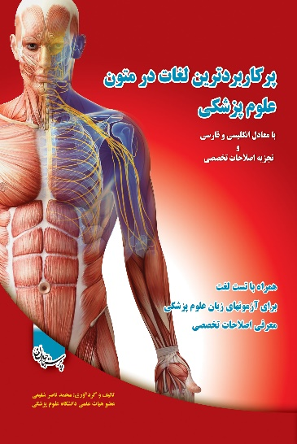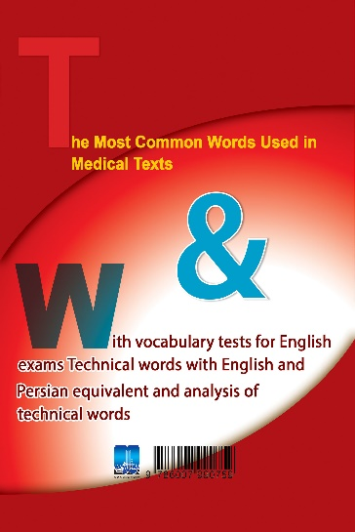

* **Training facilities:**
* Computer, Internet (Navid System and Telegram Group)
* **Type of evaluation**:
* **Cognitive tests including:**

1. Interpretive questions

2. Multiple choices (vocabularies, comprehension tests)

3. True /false

4. Matching

5. Cloze test

* **Assignments:**

1. Concept Maps

* **Examinations:**

a. During the Semester (In-class Quizzes, Midterm Exam)

b. Final Examination

|  |  |  |  |  |  |  |  |  |
| --- | --- | --- | --- | --- | --- | --- | --- | --- |
| **Mid-term** | | | **Final Exam** | | | **Class Activities** | **Extra Score** | **Total Score** |
| **Date** | **Content** | **Score/20** | **Date** | **Content** | **Score/20** |
| 1402/09/11 (Saturday)  12:00-14:00 | 4 units (1-4) | 4 | 1402/10/24 (Sunday)  10:00-12:00 | 9 units (units 5 – 16, except units 8, 14, & 15) | 14 | 2 | 1 | 20+ |

* Oral presentation, Exercises, Concept Maps, and Attendance

** Multiple Choice Questions Test

* **Rules and expectations of students (determined by English department)**

Each student is required to observe the training regulations as follows:

* Following good ethics
* Class participation
* Homework completion including well-made concept maps on specified passages of the textbook, shown in red color (Portfolio with at least 4 concept maps or one concept maps + one presentation).

**General English Course Plan**

|  |  |  |  |  |  |
| --- | --- | --- | --- | --- | --- |
| **Date** | **Subject** | **Instructor** | **Teaching**  **methodology** | **Facilities** | **Training**  **field** |
| Week 1 | Introduction & Unit 1 (Common Cold) | M. Hassanpour | Interactive teaching (lecturing & brain storming) | Computer &  Internet | Navid System & Social media |
| Week 2 | Unit 1  (Influenza and Colds) | ״ | ״ | ״ | ״ |
| Week 3 | Unit 2  (The Fight Against Wound Infections) | ״ | ״ | ״ | ״ |
| Week 4 | Unit 3 (Germs, Infection, and Disease) | ״ | ״ | ״ | ״ |
| Week 5 | Unit 4 (Meningitis; Measles) | ״ | ״ | ״ | ״ |
| Week 6 | Unit 5 (Mental and Physical Needs of a Patient) | ״ | ״ | ״ | ״ |
| Week 7 | Unit 5 (Sleeping Pills; Heat Exhaustion) | ״ | ״ | ״ | ״ |
| Week 8 | Unit 6  (Physical Fitness (I, II)) | ״ | ״ | ״ | ״ |
| Week 9 | Unit 7  (Physical Fitness (I, II)) | ״ | ״ | ״ | ״ |
| Week 10 | Unit 9  (Volunteers’ presentation) | ״ | ״ | ״ | ״ |
| Week 11 | Unit 10  (Volunteers’ presentation) | ״ | ״ | ״ | ״ |
| Week 12 | Unit 11  (Volunteers’ presentation) | ״ | ״ | ״ | ״ |
| Week 13 | Unit 12  (Volunteers’ presentation) | ״ | ״ | ״ | ״ |
| Week 14 | Unit 13  (Volunteers’ presentation) | ״ | ״ | ״ | ״ |
| Week 15 | Unit 16  (Volunteers’ presentation) | ״ | ״ | ״ | ״ |

**Second Semester, 1401-1402**